**Power BI Hands-on Assessment**

* Created a new database named ‘retaildb’ and loaded the tables in it.

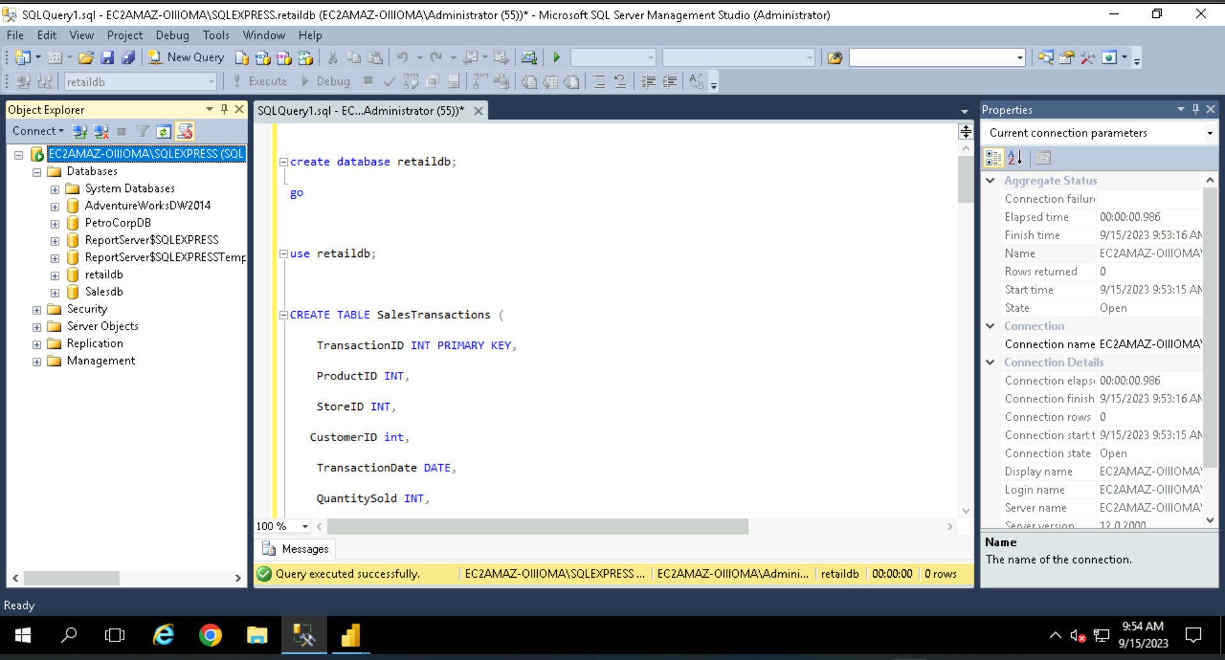

* Importing all the tables from the sql server into Power BI.

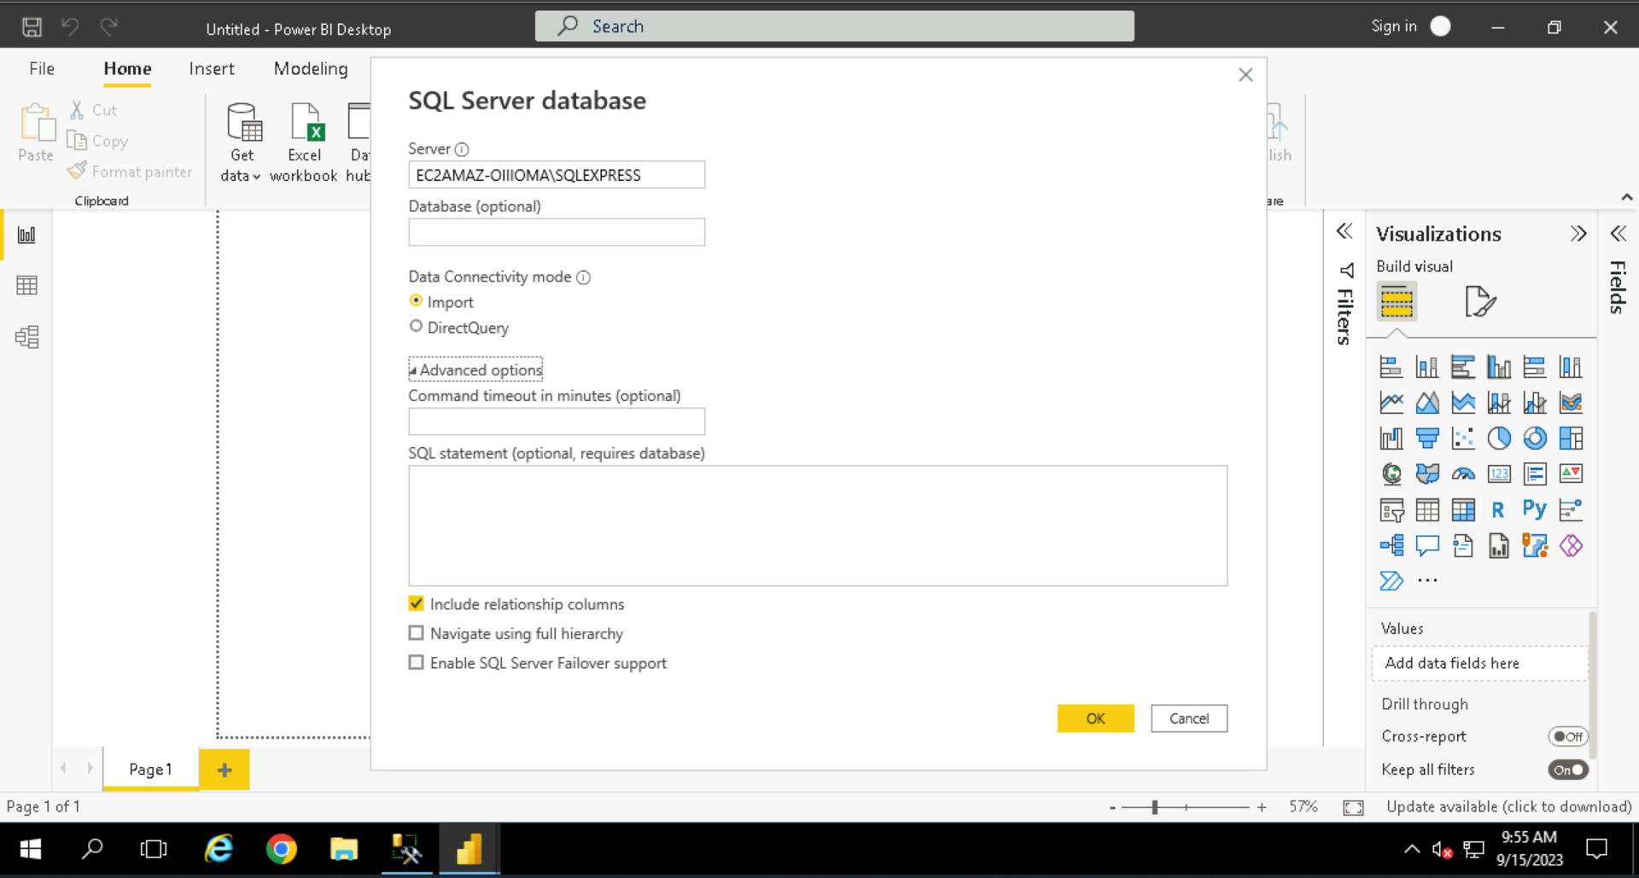

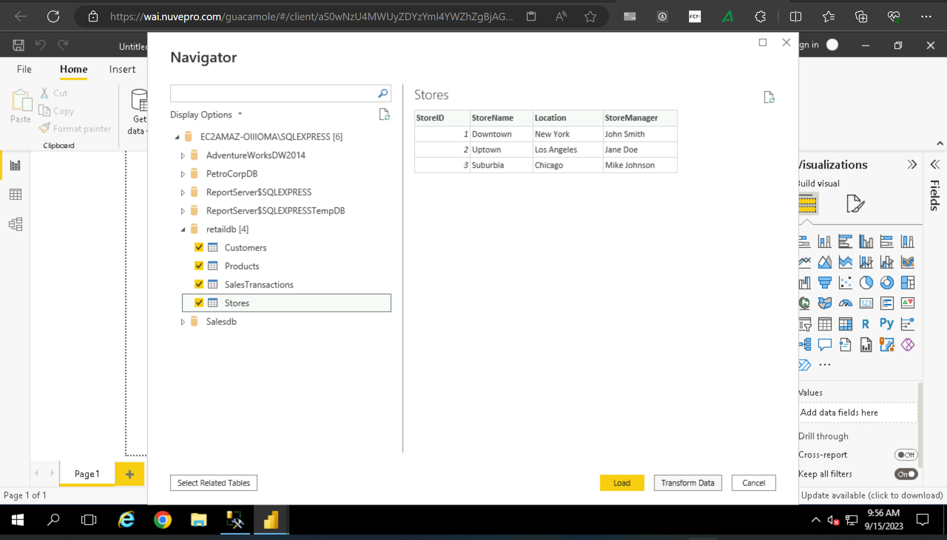

* Data Transformation: Merging the tables.

Merged the Sales transaction and customer tables based on customer id.

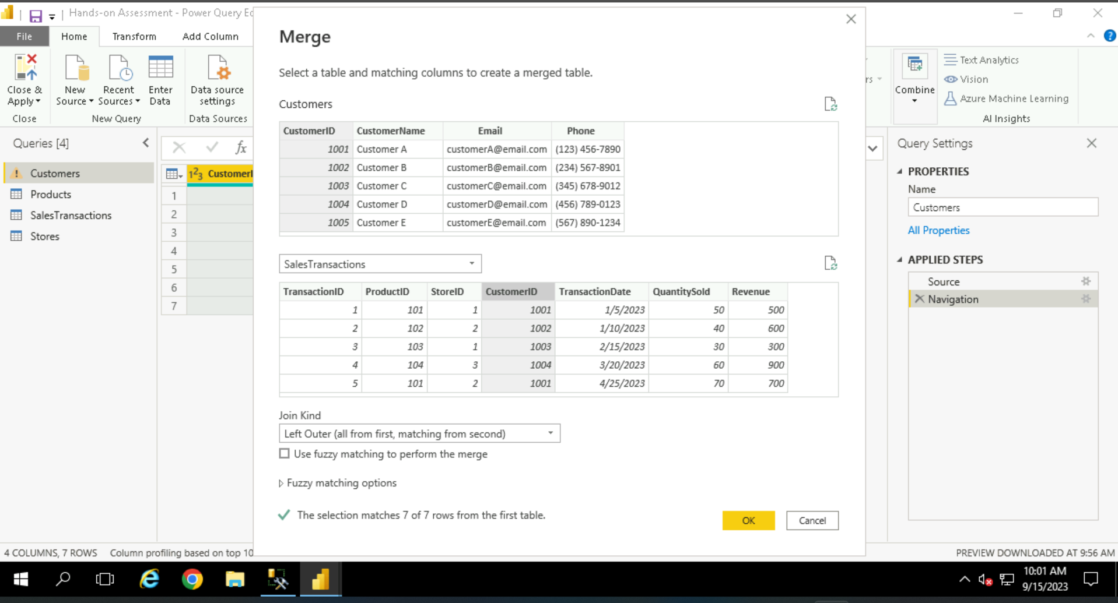

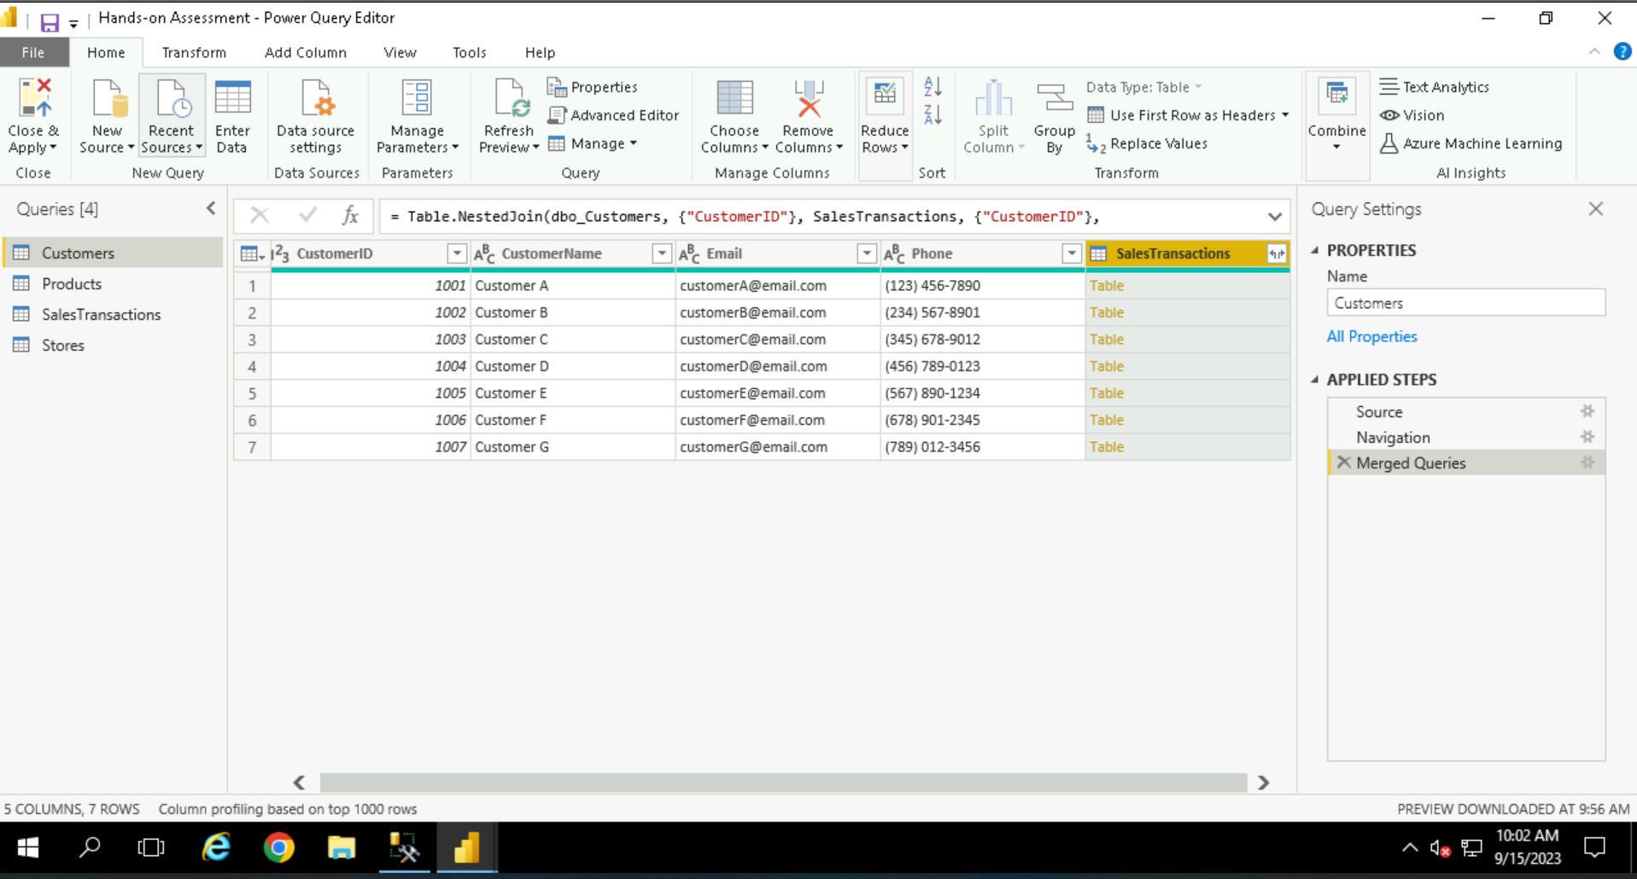

* Clean data by removing null values, clicking on remove empty option.

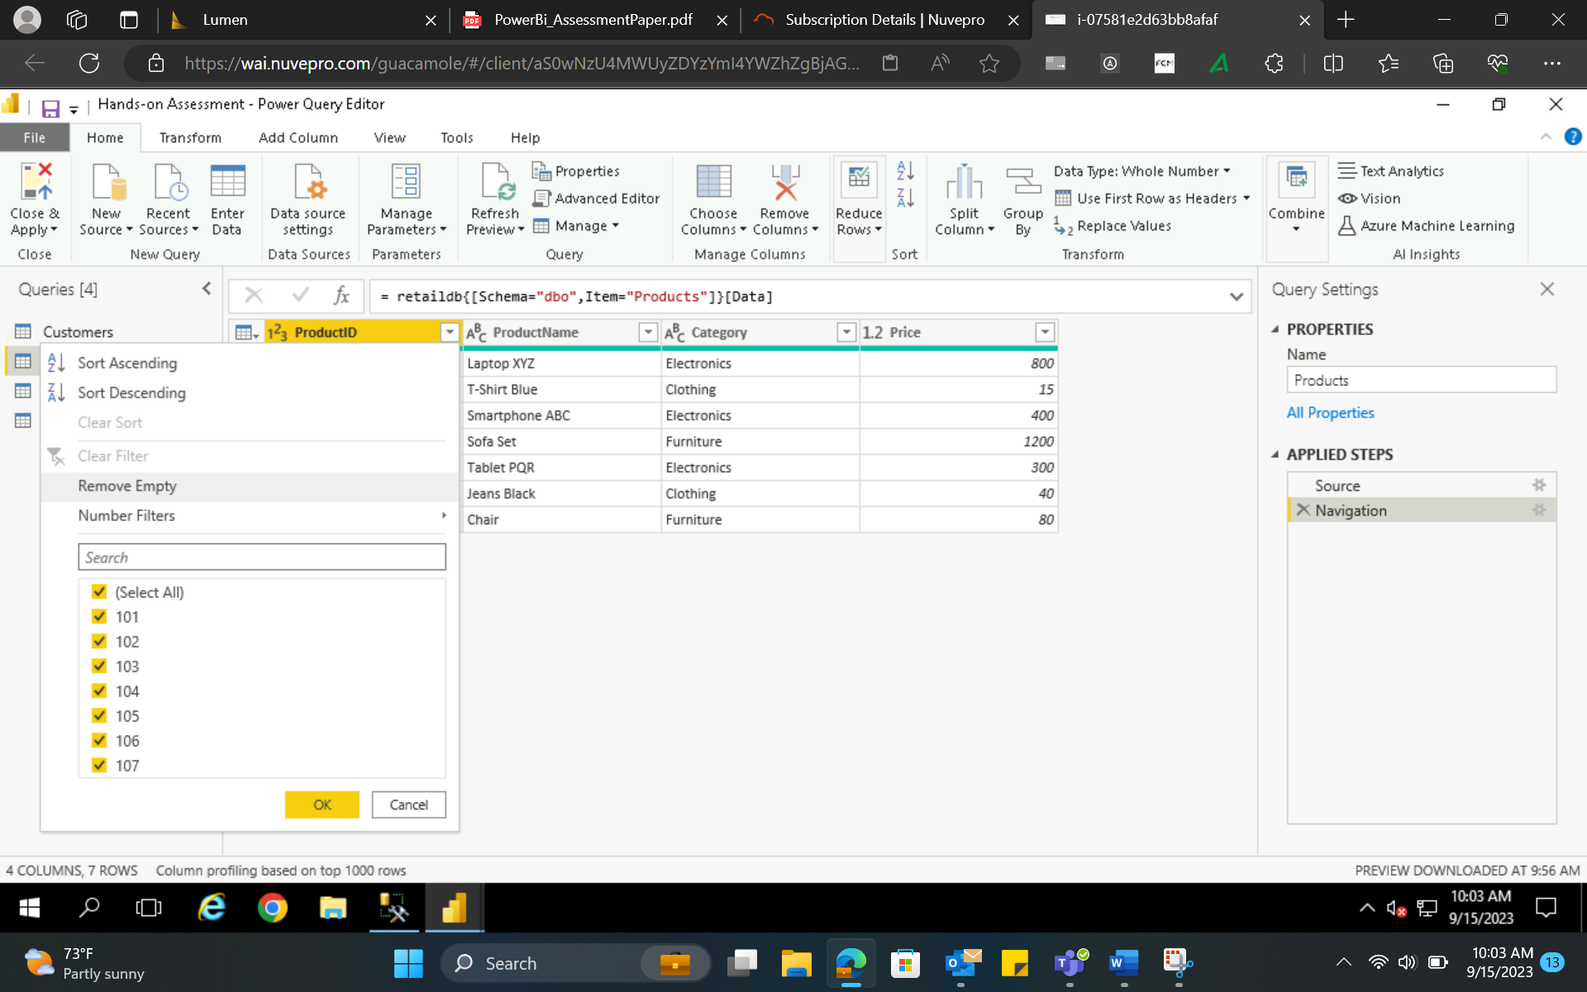

* Calculated columns: Added a new column named ‘Revenue’

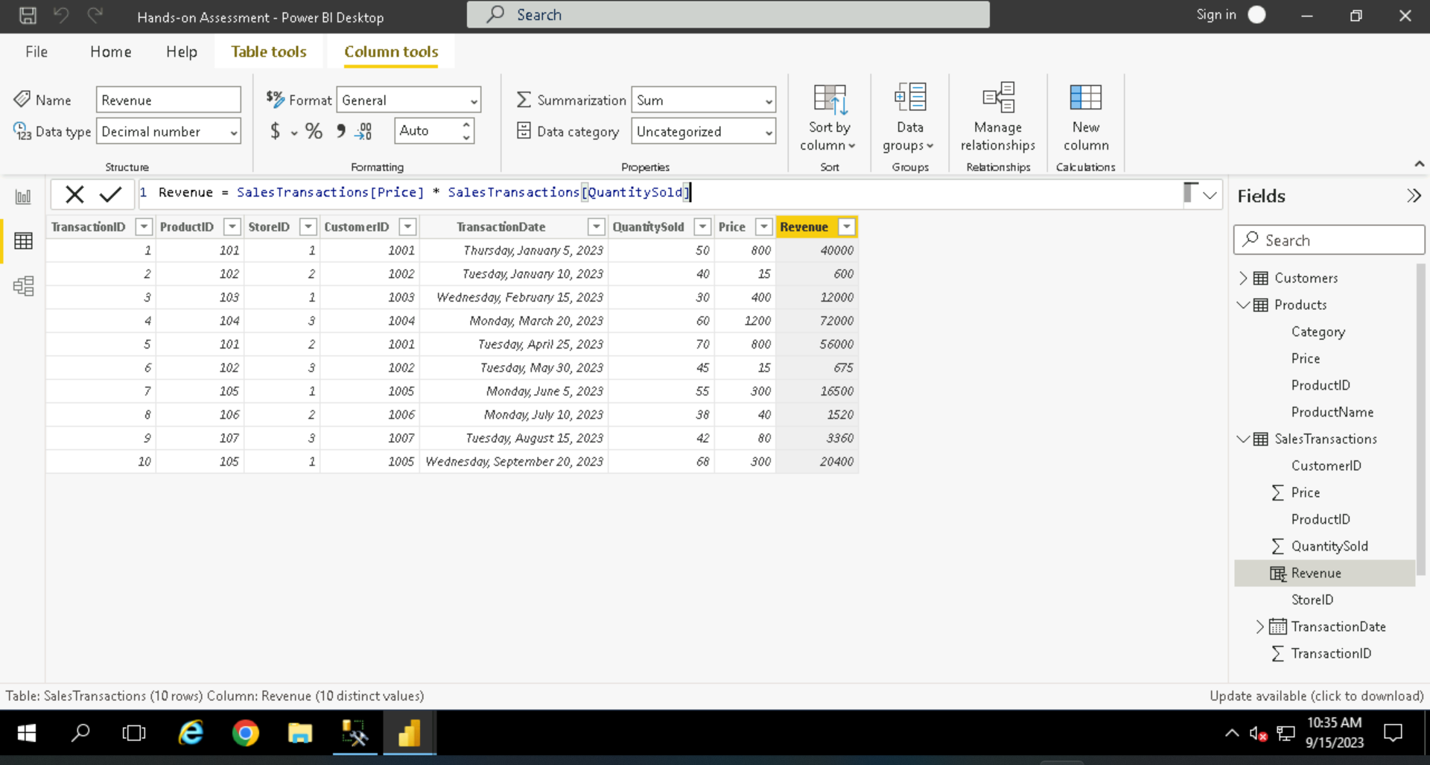

* Used a number filter to filter the revenue.

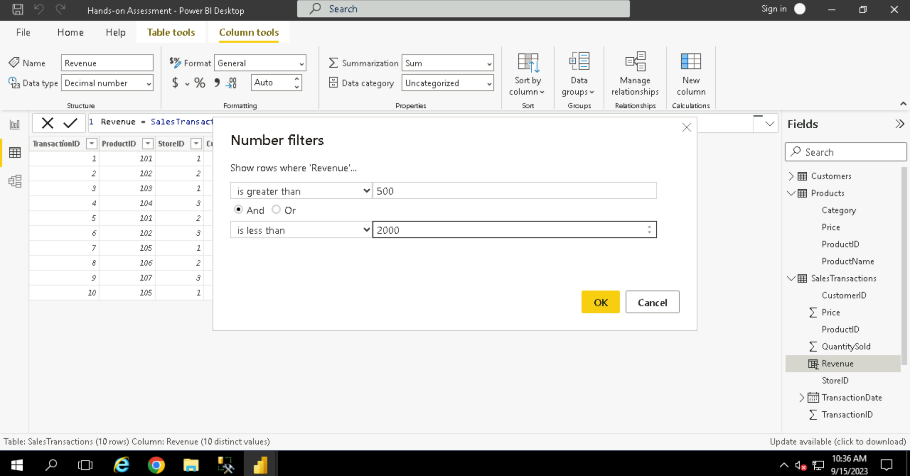

* Creating relationships

Created a relationship between SalesTransactions and products based on price column.

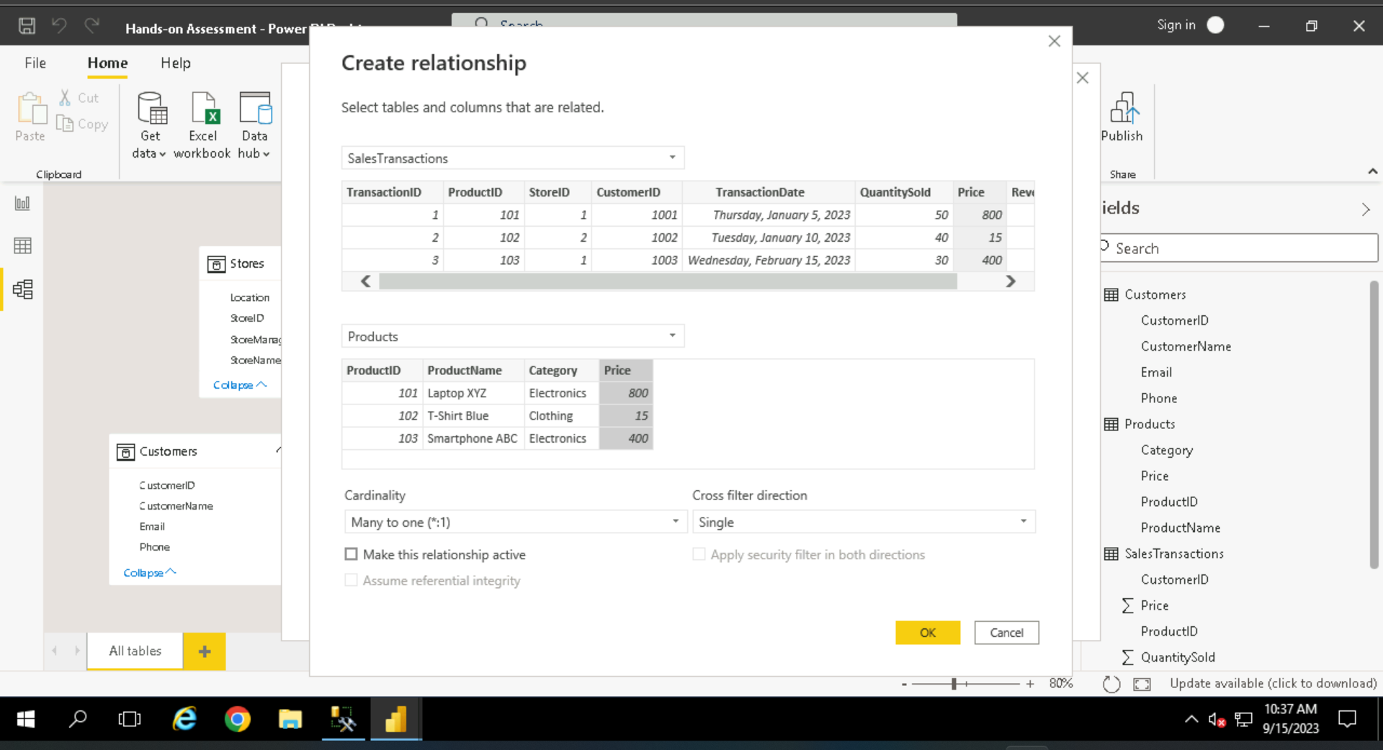

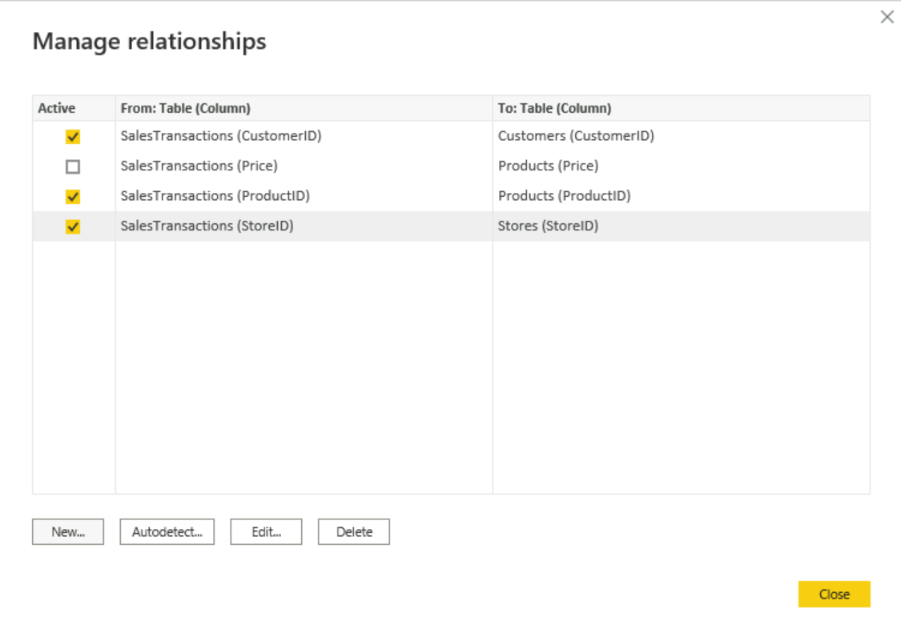

* Hierarchy creation. Created a StoreName Hierarchy.

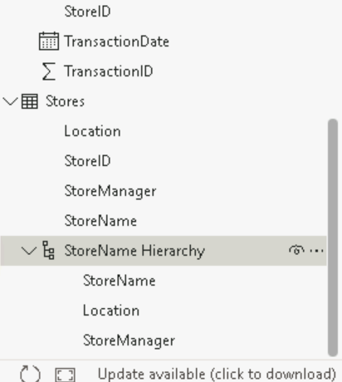

* Business Queries and analysis

1. Who are the top-spending customers based on their total purchase amount?

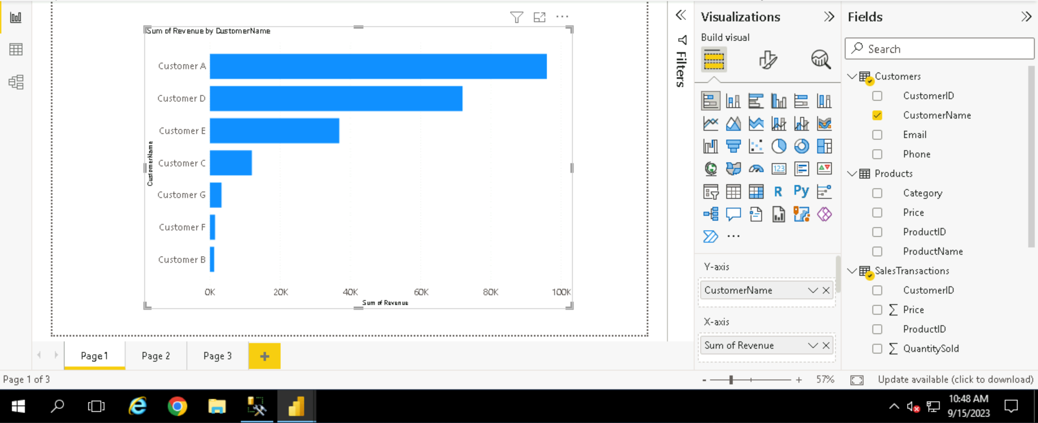

1. How is sales revenue distributed among different store managers?

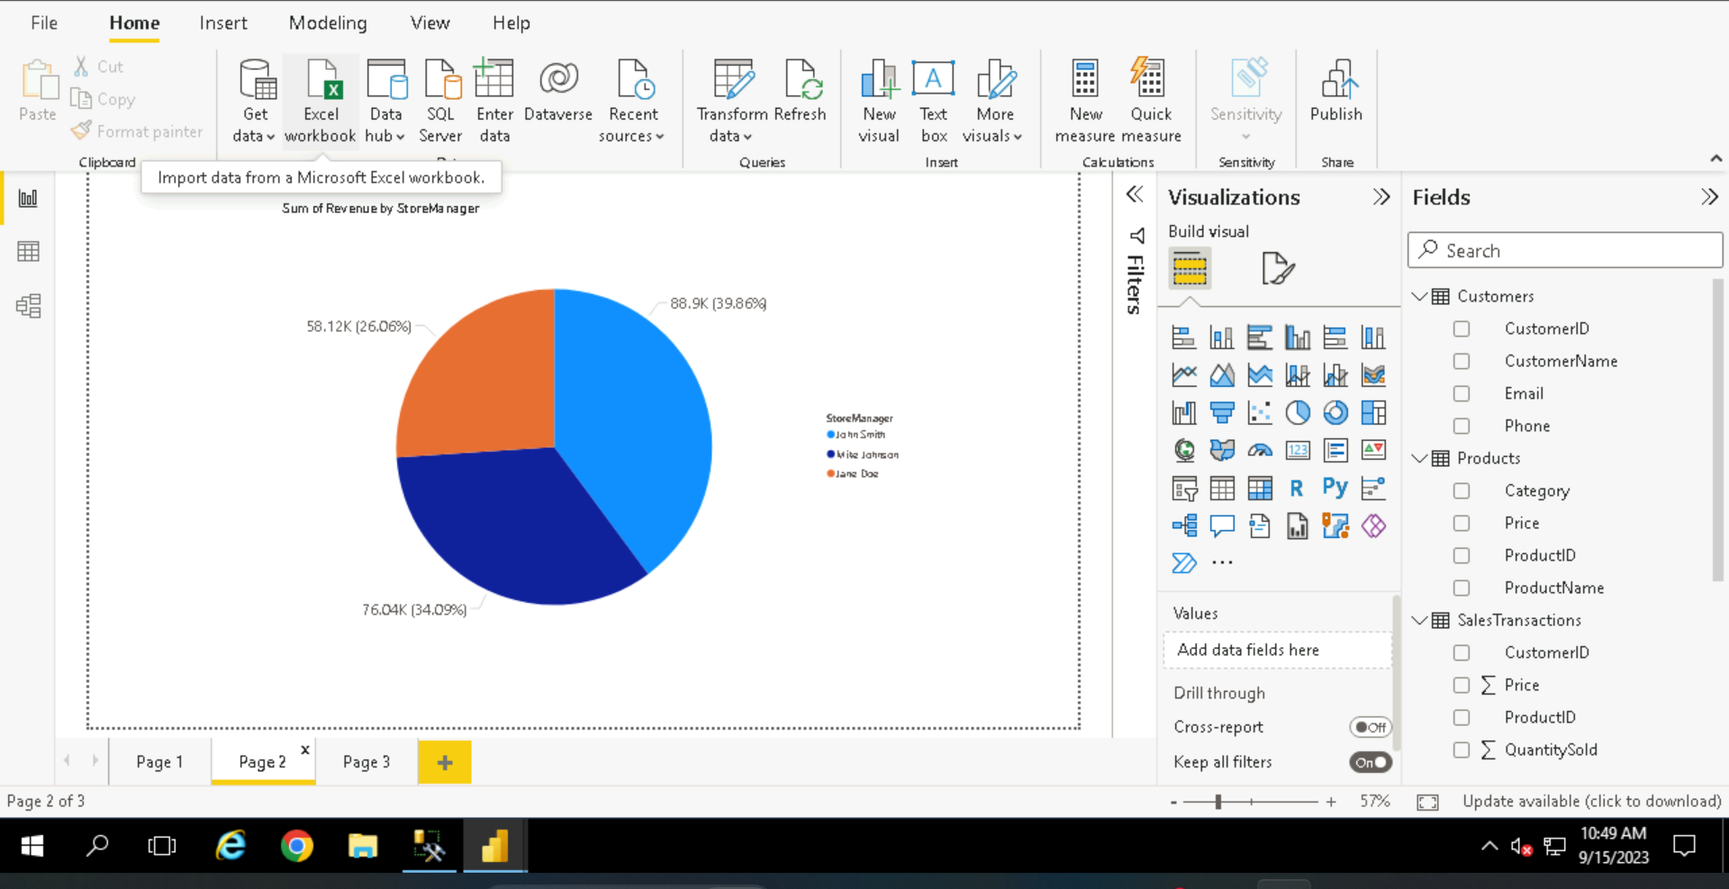

1. What is the average price of products in each category?

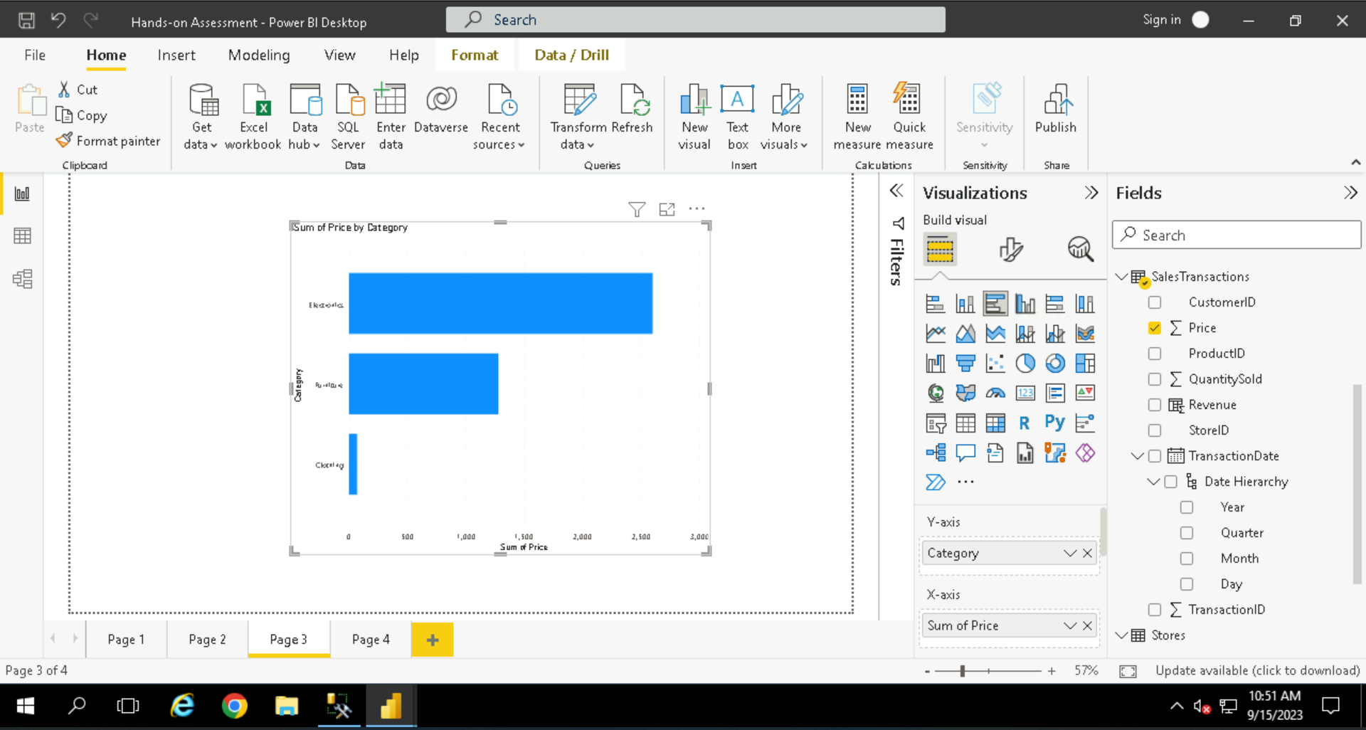

1. Are there specific days of the week when sales are higher?

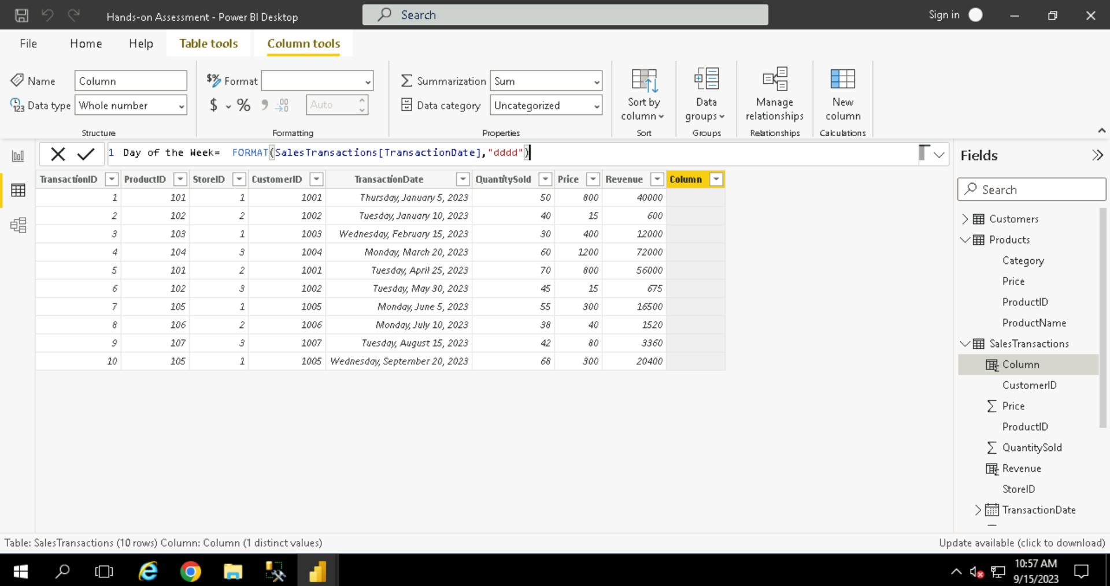

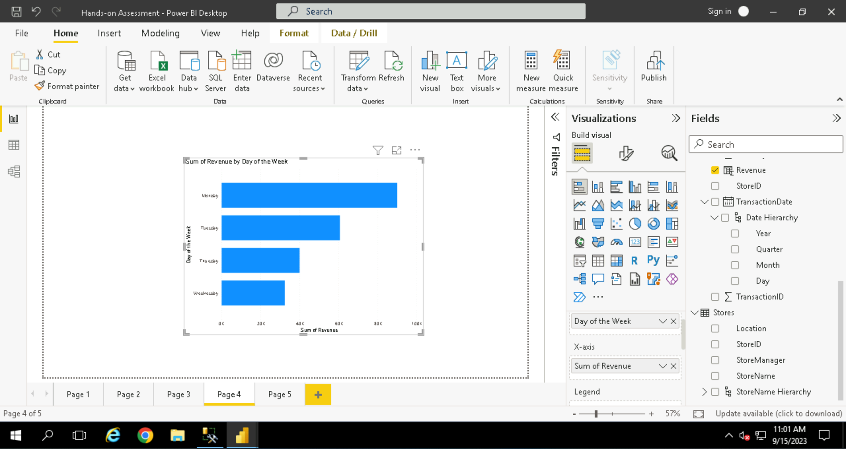

1. How do sales trends vary by product category on a monthly basis?

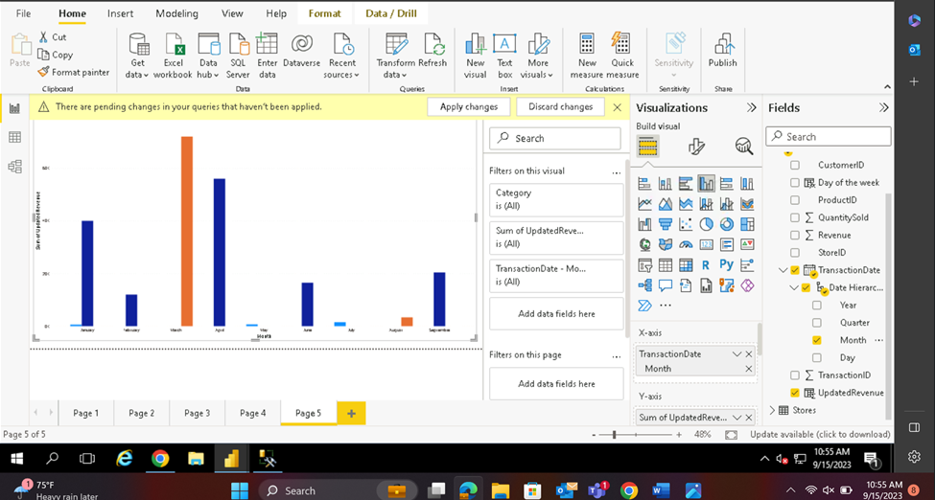

1. What percentage of products account for 80% of total sales revenue?

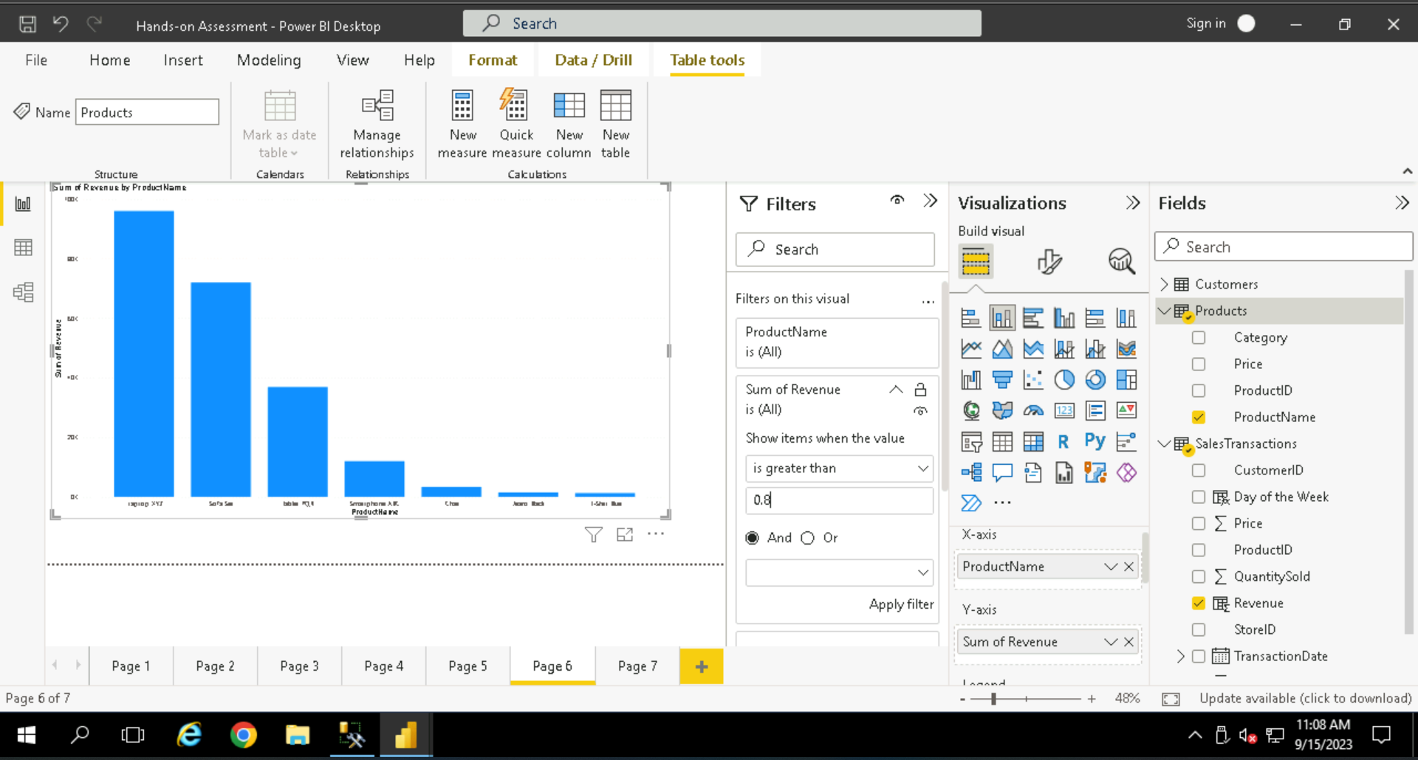

1. Are there any trends in repeat customer purchases?

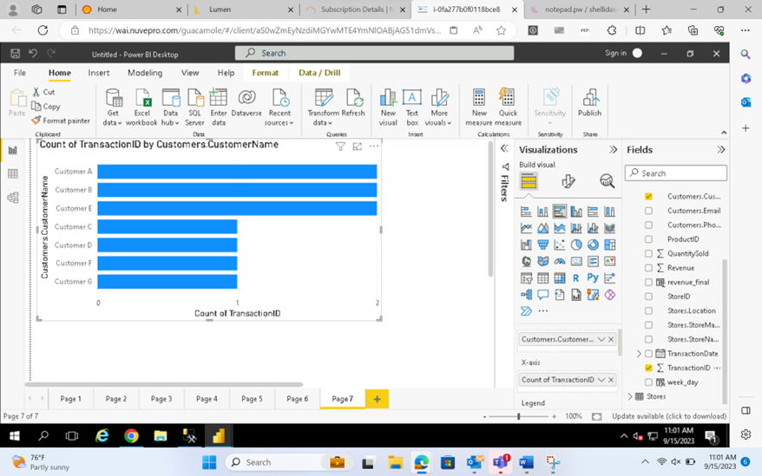

1. Which product categories perform best at each store loca;on?

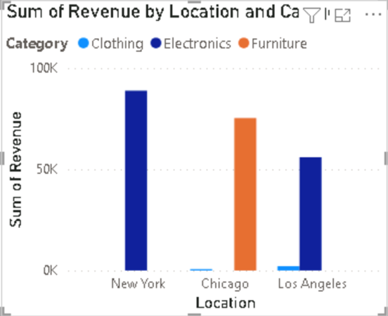

1. Are there any seasonal paSerns or trends in sales for specific products or categories?

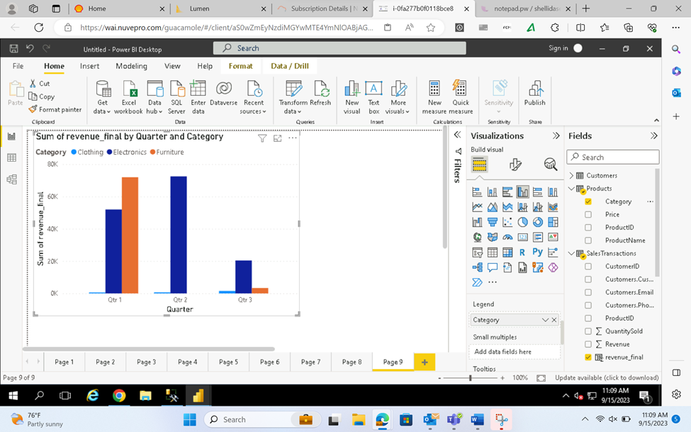

10. Can customers be segmented into high, medium, and low-value segments based on their

purchase history.

